Item pic / Artikelbild | Description / Beschreibung | 3,5 /  36 | 4 /  37 | 5 /  38 | 6 /  39 | 6,5 /  40 | 7,5 /  41 | 8 /  42 | QTY / Menge | RRP / UVP
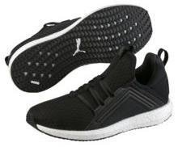 | Mega NRGY Wn's  190369-01  Puma Black | 0 | 219 | 438 | 657 | 438 | 438 | 0 | 2.190 | 64,95 €
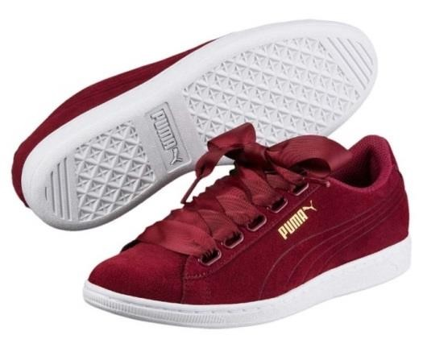 | Vikky Ribbon  364262-03  Tibetan Red-Tib | 341 | 316 | 570 | 1.008 | 489 | 153 | 0 | 2.877 | 59,95 €
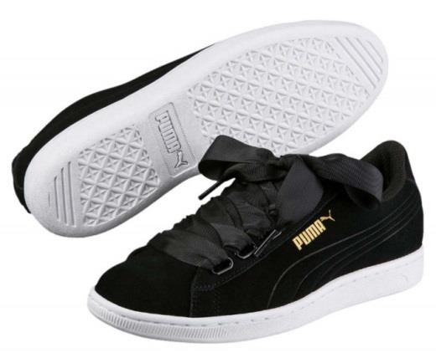 | Vikky Ribbon  364262-03  Puma Black-Puma | 164 | 14 | 171 | 71 | 224 | 0 | 285 | 929 | 59,95 €

TOTAL 505 549 1.179 1.736 1.151 591 285 5.996 61,78 €

